PIE CHART
Pearson Edexcel - Tuesday 11 June 2019 - Paper 3 (Calculator) Higher Tier
1.
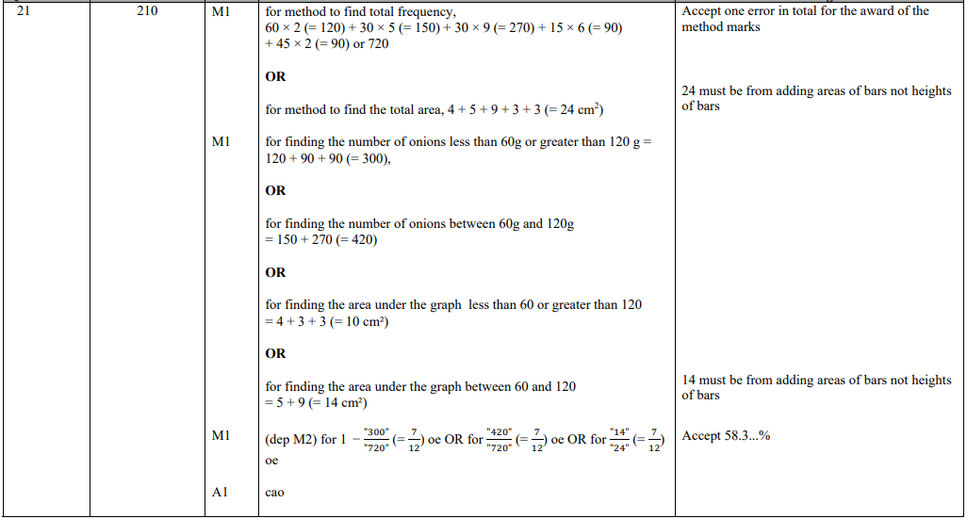
Pearson Edexcel - Monday 6 November 2017 - Paper 2 (Calculator) Higher Tier
2.
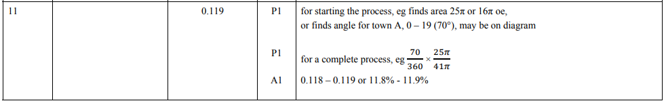
Pearson Edexcel - Thursday 8 November 2012 - Paper 2 (Calculator) Higher Tier
3.
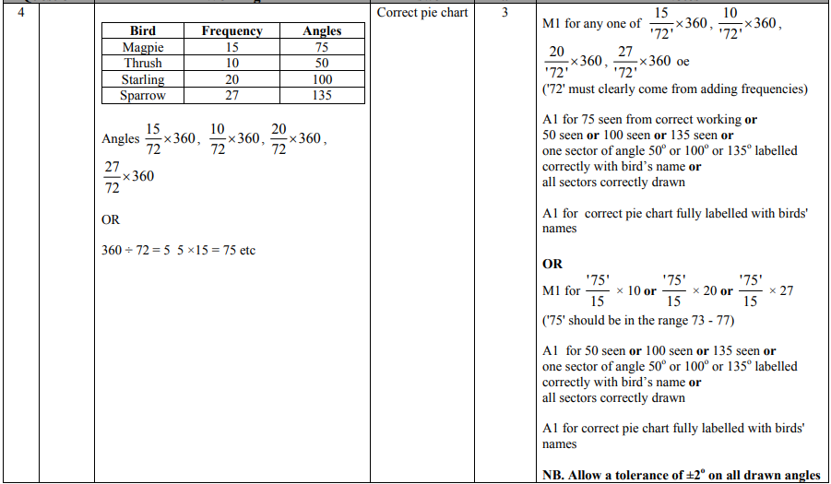
AQA GSCE – Thursday 8 June 2017 – Paper 2 (Calculator) Higher Tier
4.
